**A PROJECT REPORT**

**ON**

**“IKEA (FRAME SECTION) WEB SCRAPING”**

**PROJECT FOR PYTHON MODULE**

**SUBMITTED IN PARTIAL FULFILLMENT OF THE REQUIREMENTS**

**BY**

**SUSMITA SANDIP PAWAR**

**UNDER THE GUIDENCE OF**

**MR. SAMEER WARSOLKAR**



**MASTER IN DATA SCIENCE & ANALYTICS WITH AI**

**INSTITUTE OF IT VENDANT**

**BRANCH – THANE (3 to 5)**

**COURSE CODE - T305**

**DATE – 12-08-2023**

**Aim:** Creating a web scraping project for the frame section of the IKEA website can be a useful task for various purposes, such as frame names, frame size, or market research on price and rating.

Here's a step-by-step guide to help you get started

# Description:

Ikea (frame section) web scraping project involves extracting data from websites by automating the process using scripts or software. This data can be used for various purposes, such as data analysis, research, reporting, or populating databases.

This database contains 4 tables:

1. Frame name

2. Frame size

3. Frame price

4. Frame rating

**2 . Choose a Programming Language:**

Decide on a programming language for web scraping project. Python is a popular choice due to its rich ecosystem of libraries, including BeautifulSoup and Scrapy, which are excellent for web scraping.

**3. Install Required Libraries:**

Install the necessary libraries. I am using the pip to install BeautifulSoup and requests if /’’decide to go with Python:

Output:

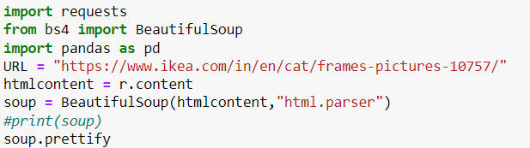

**4. Identify the Target URL:**

Determine the URL of the IKEA webpage that contains the frame section want to scrape. For example:

URL = <https://www.ikea.com/in/en/cat/frames-pictures-10757/>

**5. Send HTTP Request:**

Use the requests library to send an HTTP GET request to the target URL and retrieve the webpage's HTML content.

Output:

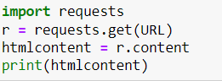

**6. Parse the HTML:**

Use BeautifulSoup to parse the HTML content and extract the relevant information. Inspect the HTML source code of the webpage to identify the elements want to scrape, such as frame names, prices, and size.

Output:



**7. Extract Data:**

Continue to extract the data you need, such as prices and rating. Be mindful of the website's terms of service and use rate-limiting to avoid overloading the server with requests.

**8. Data Storage:**

Decide how and where you will store the scraped data. Common options include

CSV files, databases.

**Ikea (frames section) web scraping coding command as follows:**

* Access the title from ikea web for the frame section

Output:

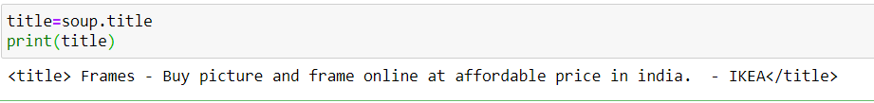

* Access the frame names from ikea web for the frame section by using the following class

Output:

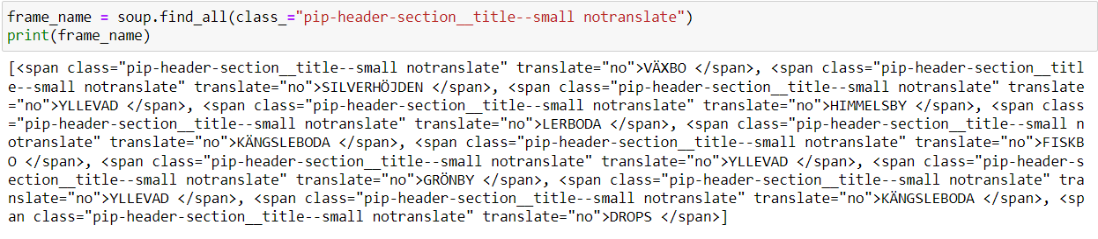

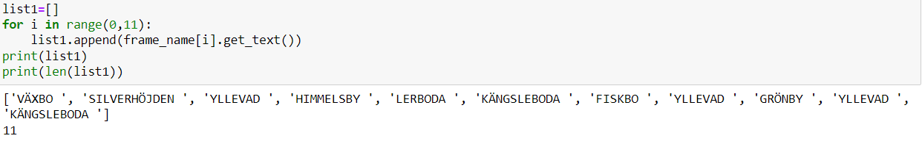

* Access the frame size from ikea web for the frame section by using the following class

Output:

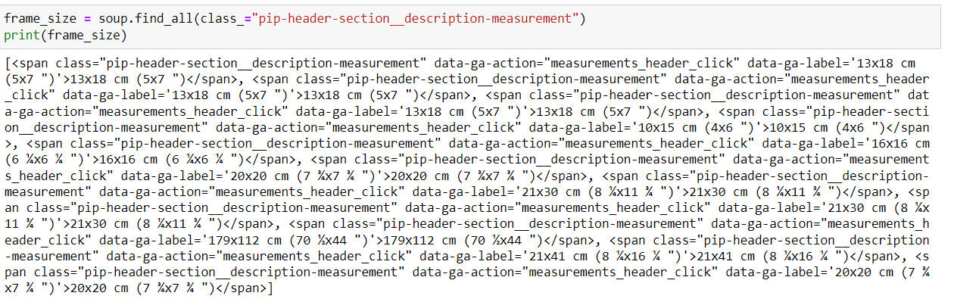

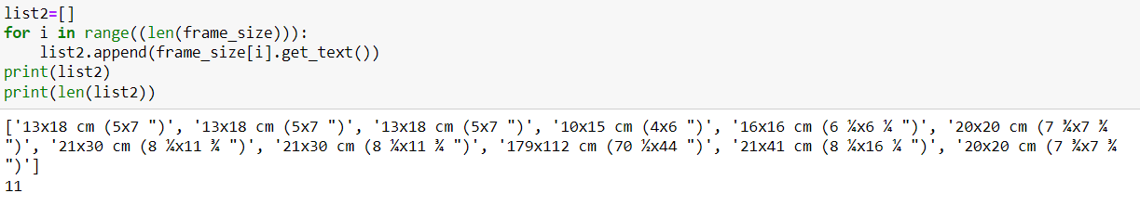

* Access the frame price from ikea web for the frame section by using the following class

Output:

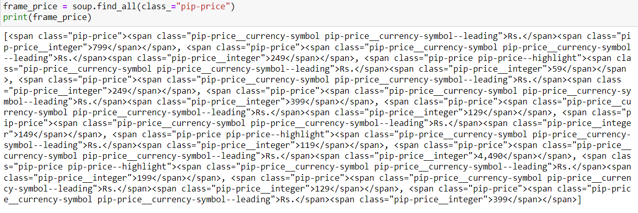

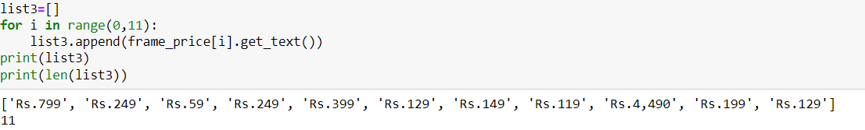

* Access the frame rating from ikea web for the frame section by using the following class

Output:

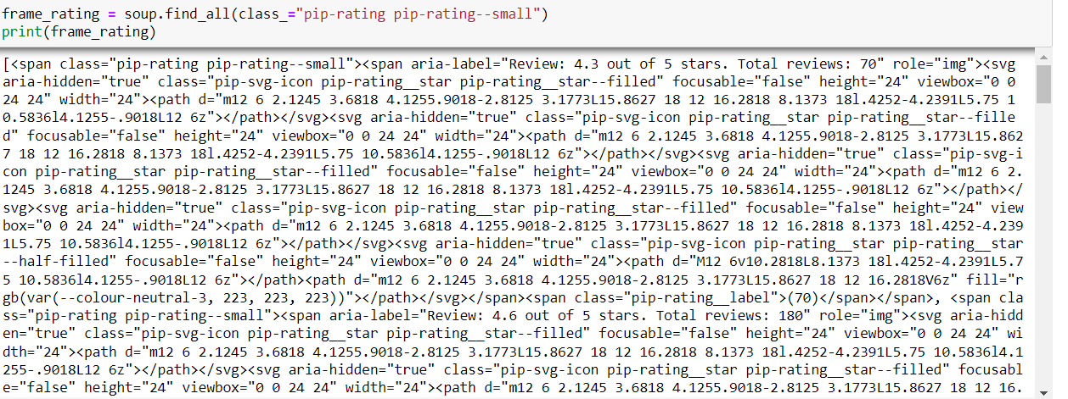

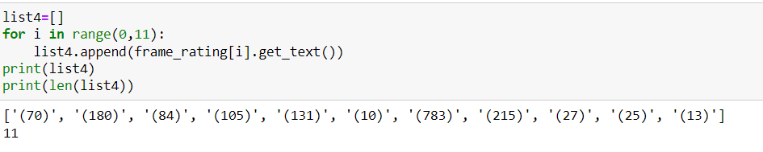

* Then arrange properly in column all above data by using import pandas library.

Output:

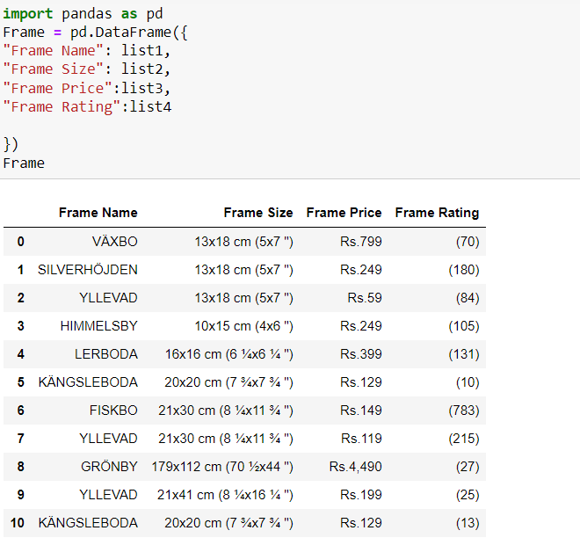

* Then store above all data in CSV file and again open this file in application

Output:

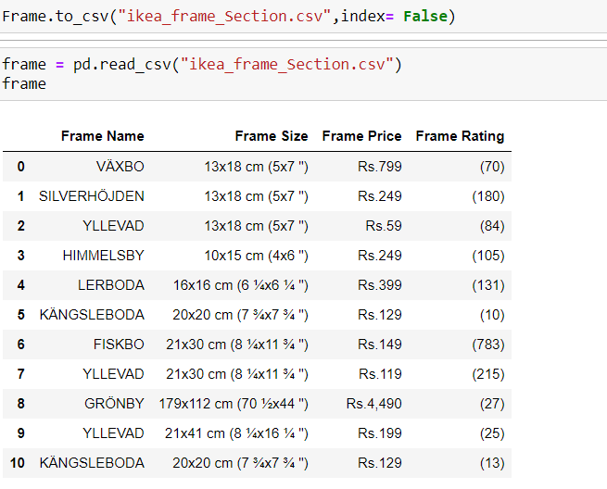

* Here the 2nd frame section from ikea web and the data frame is created

Output:

